Pojmenuj dopravní prostředky a spoj jejich množství se správnou kostkou.

C:\Users\Karkošková\AppData\Local\Microsoft\Windows\Temporary Internet Files\Content.IE5\UJ0WUVXC\MC900234470[1].wmfC:\Users\Karkošková\AppData\Local\Microsoft\Windows\Temporary Internet Files\Content.IE5\3ZNZD1MT\MC900295602[1].wmfC:\Users\Karkošková\AppData\Local\Microsoft\Windows\Temporary Internet Files\Content.IE5\3ZNZD1MT\MC900295602[1].wmfC:\Users\Karkošková\AppData\Local\Microsoft\Windows\Temporary Internet Files\Content.IE5\3ZNZD1MT\MC900295602[1].wmfC:\Users\Karkošková\AppData\Local\Microsoft\Windows\Temporary Internet Files\Content.IE5\13XKCWY4\MC900413626[1].wmfC:\Users\Karkošková\AppData\Local\Microsoft\Windows\Temporary Internet Files\Content.IE5\13XKCWY4\MC900413626[1].wmfC:\Users\Karkošková\AppData\Local\Microsoft\Windows\Temporary Internet Files\Content.IE5\P5RTMTQY\MC900287336[1].wmfC:\Users\Karkošková\AppData\Local\Microsoft\Windows\Temporary Internet Files\Content.IE5\P5RTMTQY\MC900287336[1].wmfC:\Users\Karkošková\AppData\Local\Microsoft\Windows\Temporary Internet Files\Content.IE5\P5RTMTQY\MC900287336[1].wmfC:\Users\Karkošková\AppData\Local\Microsoft\Windows\Temporary Internet Files\Content.IE5\P5RTMTQY\MC900287336[1].wmfC:\Users\Karkošková\AppData\Local\Microsoft\Windows\Temporary Internet Files\Content.IE5\P5RTMTQY\MC900287336[1].wmfC:\Users\Karkošková\AppData\Local\Microsoft\Windows\Temporary Internet Files\Content.IE5\P4Z57OO0\MC900413620[1].wmfC:\Users\Karkošková\AppData\Local\Microsoft\Windows\Temporary Internet Files\Content.IE5\P4Z57OO0\MC900413620[1].wmfC:\Users\Karkošková\AppData\Local\Microsoft\Windows\Temporary Internet Files\Content.IE5\QJ8PA6JK\MC900424188[1].wmfC:\Users\Karkošková\AppData\Local\Microsoft\Windows\Temporary Internet Files\Content.IE5\QJ8PA6JK\MC900424188[1].wmfC:\Users\Karkošková\AppData\Local\Microsoft\Windows\Temporary Internet Files\Content.IE5\QJ8PA6JK\MC900424188[1].wmfC:\Users\Karkošková\AppData\Local\Microsoft\Windows\Temporary Internet Files\Content.IE5\QJ8PA6JK\MC900424188[1].wmf

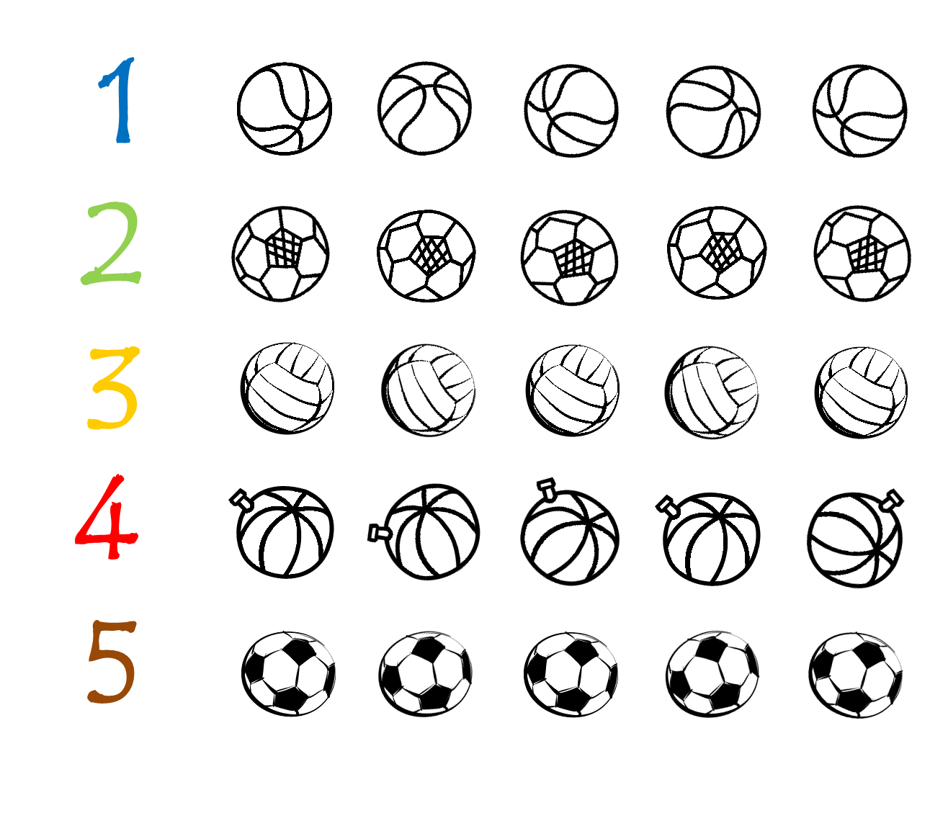Podle číslice vybarvi množství balonů.

Vybarvi tolik puntíků, kolik je květů.

C:\Users\Karkošková\AppData\Local\Microsoft\Windows\Temporary Internet Files\Content.IE5\12IOP452\MC900123273[1].wmfC:\Users\Karkošková\AppData\Local\Microsoft\Windows\Temporary Internet Files\Content.IE5\3ZNZD1MT\MC900122853[1].wmfC:\Users\Karkošková\AppData\Local\Microsoft\Windows\Temporary Internet Files\Content.IE5\0YOEXXWK\MC900305485[1].wmfC:\Users\Karkošková\AppData\Local\Microsoft\Windows\Temporary Internet Files\Content.IE5\0YOEXXWK\MC900305485[1].wmfC:\Users\Karkošková\AppData\Local\Microsoft\Windows\Temporary Internet Files\Content.IE5\P5RTMTQY\MC900123171[1].wmfC:\Users\Karkošková\AppData\Local\Microsoft\Windows\Temporary Internet Files\Content.IE5\52MSHM7J\MC900122781[1].wmfC:\Users\Karkošková\AppData\Local\Microsoft\Windows\Temporary Internet Files\Content.IE5\SOMK2TNF\MC900123299[1].wmf

